SRS

Powerful Women

First web application

Hadeel Hassan

February 2023

### Table of Contents

1. Introduction…………………………………………….3
2. Functional Requirements…………………………3
3. Non-functional Requirements………………….3
4. Technologies ……………………………………………4
5. Assumptions and Constraints……………………4
6. Future Enhancements………………………………..4

**Software Requirements Specification (SRS)**

1. **Introduction:**

The Women website is a Flask-based web application that allows visitors to view and rate women's profiles, add new profiles, leave reviews, and contact the website owners.

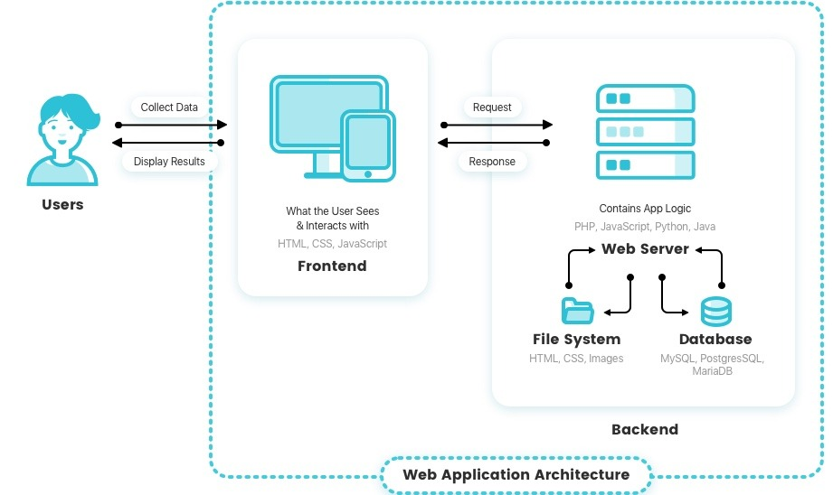

1. **Functional Requirements:**

* Homepage The homepage displays information about all women stored in the database. It allows users to rate women and view reviews.
* Add Profile The 'Add Profile' page displays a form that allows the user to add a new woman to the database. The user must provide the woman's name, position, company, country, birth date, about information, and upload an image file. The image file must be a PNG, JPG, JPEG, GIF, or JFIF file format and should not exceed 16 MB in size.
* About Us The 'About Us' page displays information about the website.
* Woman Information The 'Woman Information' page displays information about a specific woman, including her name, position, company, country, birth date, about information, and uploaded image. It also shows the woman's rating and reviews left by other visitors.
* Delete Profile The 'Delete Profile' feature allows the website owners to delete a woman's profile from the database. The owner must provide the profile's ID number to delete the profile.
* Display Image The 'Display Image' feature allows the user to view the image of a specific woman's profile.
* Contact Us The 'Contact Us' page displays a form that allows the user to submit their contact information and message to the website owners.

1. **Non-functional Requirements**

* Performance The Women website should load quickly and respond to user actions without delay.
* Security The website should be secure and prevent unauthorized access to the database and website files. It should also prevent the upload of malicious files.
* Usability The website should be easy to use and navigate. It should provide clear instructions on how to use its features.

1. **Technologies**

* 4.1 Flask - Python web framework
* 4.2 SQL Alchemy - Object-relational mapping library
* 4.3 SQLite - Database management system
* 4.4 HTML/CSS - Web markup and styling languages

1. **Assumptions and Constraints**

* The website will only support the file formats PNG, JPG, JPEG, GIF, and JFIF for image uploads.
* The maximum file size for image uploads is 16 MB.
* The website owners will manually moderate and approve all user-submitted content, including reviews and contact messages.
* The website will be hosted on a server with adequate resources to handle expected traffic.

1. **Future Enhancements**

* Implement user authentication and authorization features.
* Add social media integration for sharing profiles and reviews
* Implement a search feature to allow users to search for women based on specific criteria.